20190307

all idea submission fields are required can we have a disclaimer field then unlock the other fields when the disclaimer is agreed to

20190306

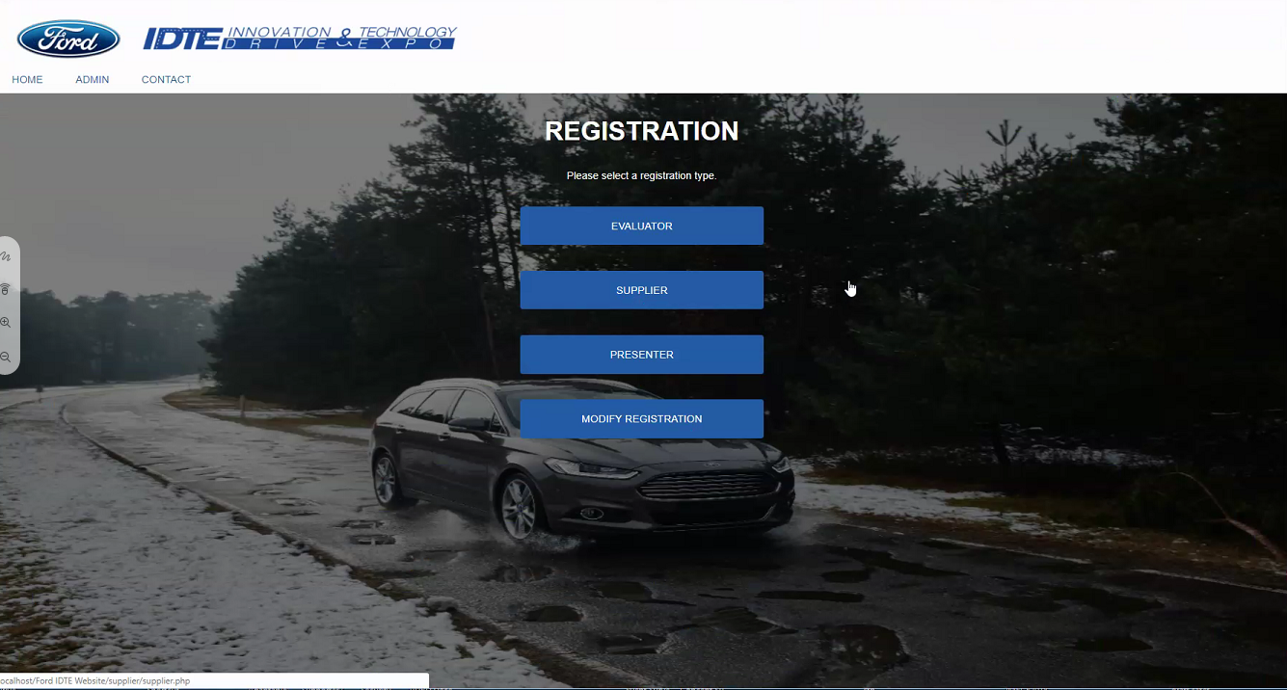

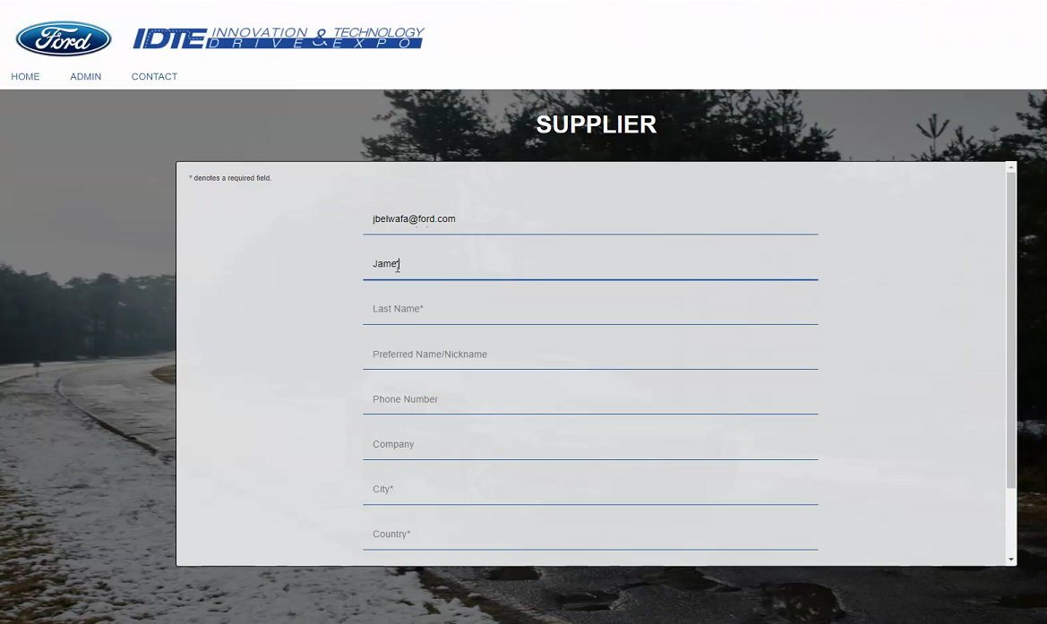

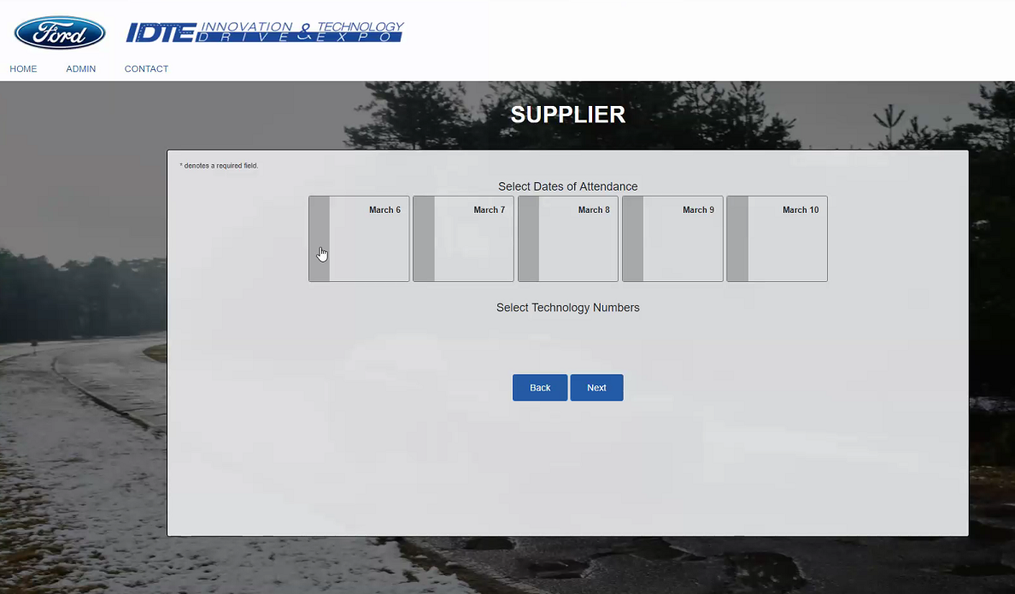

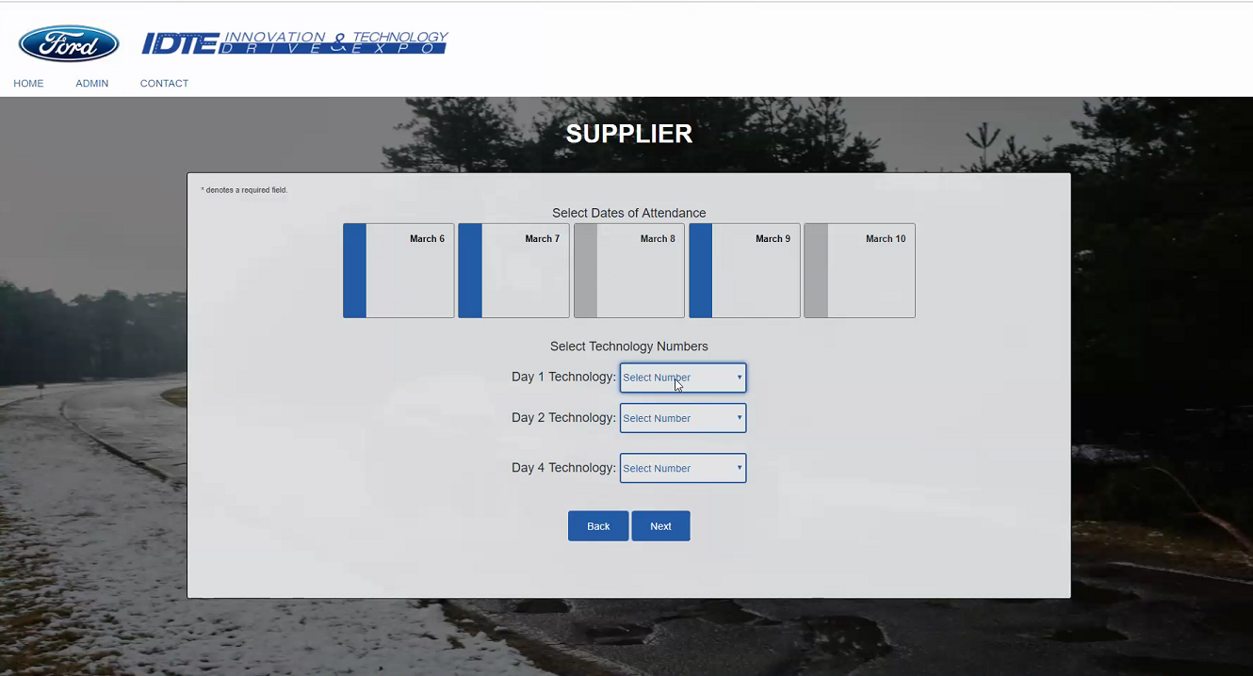

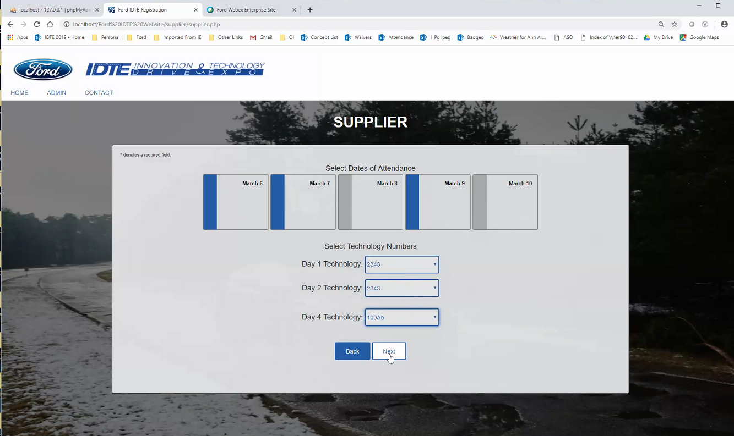

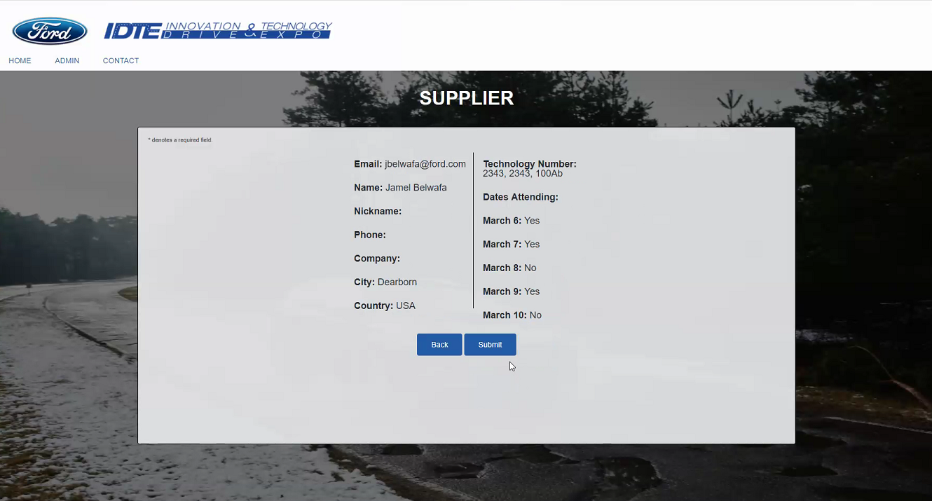

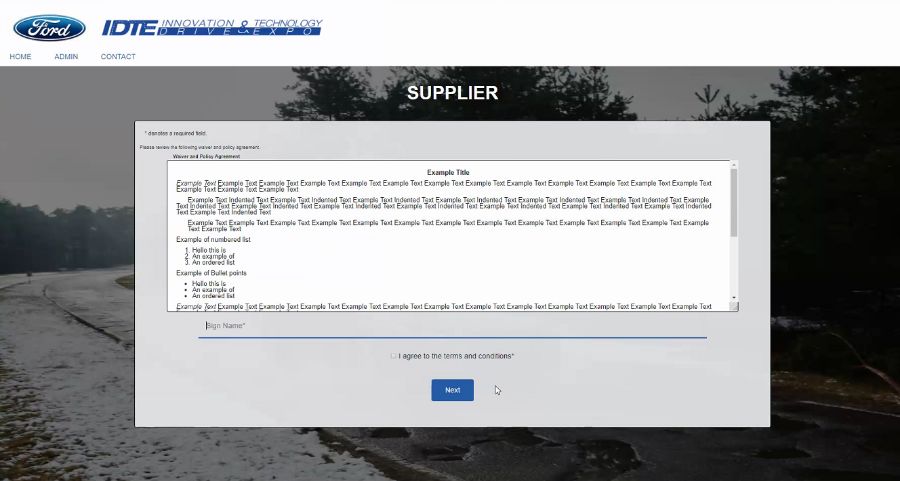

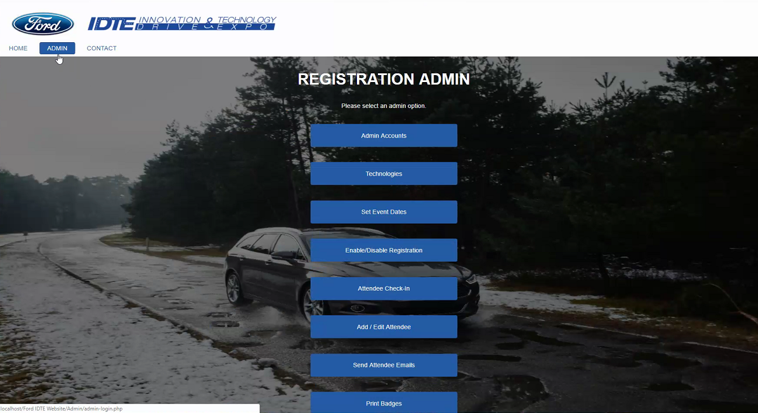

CHECK IN PEOPLE

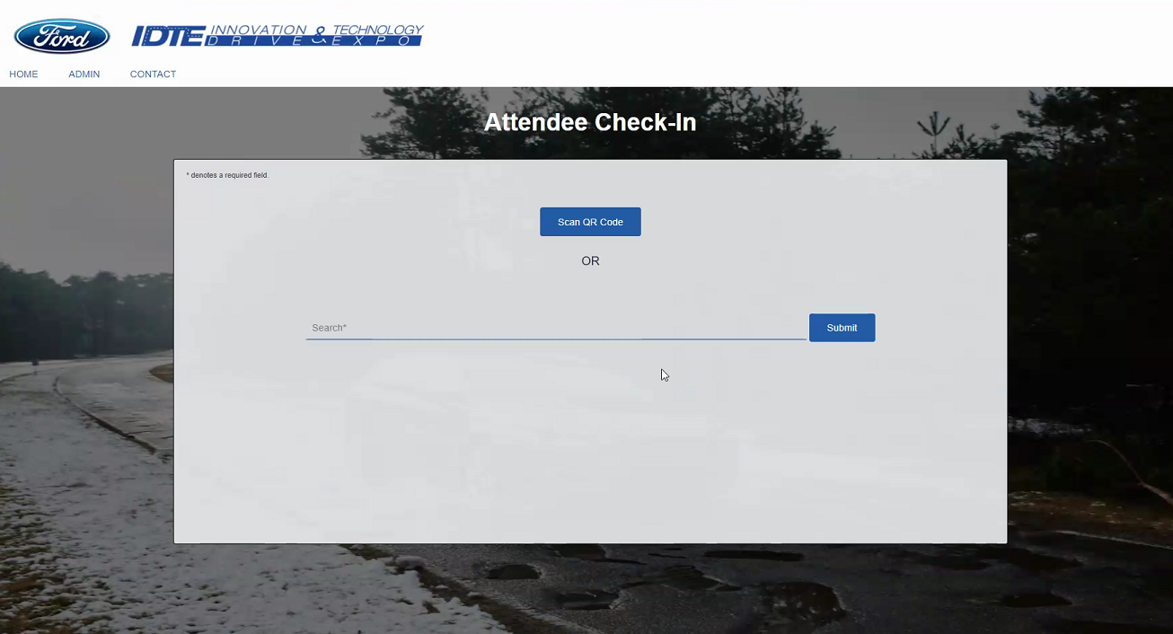

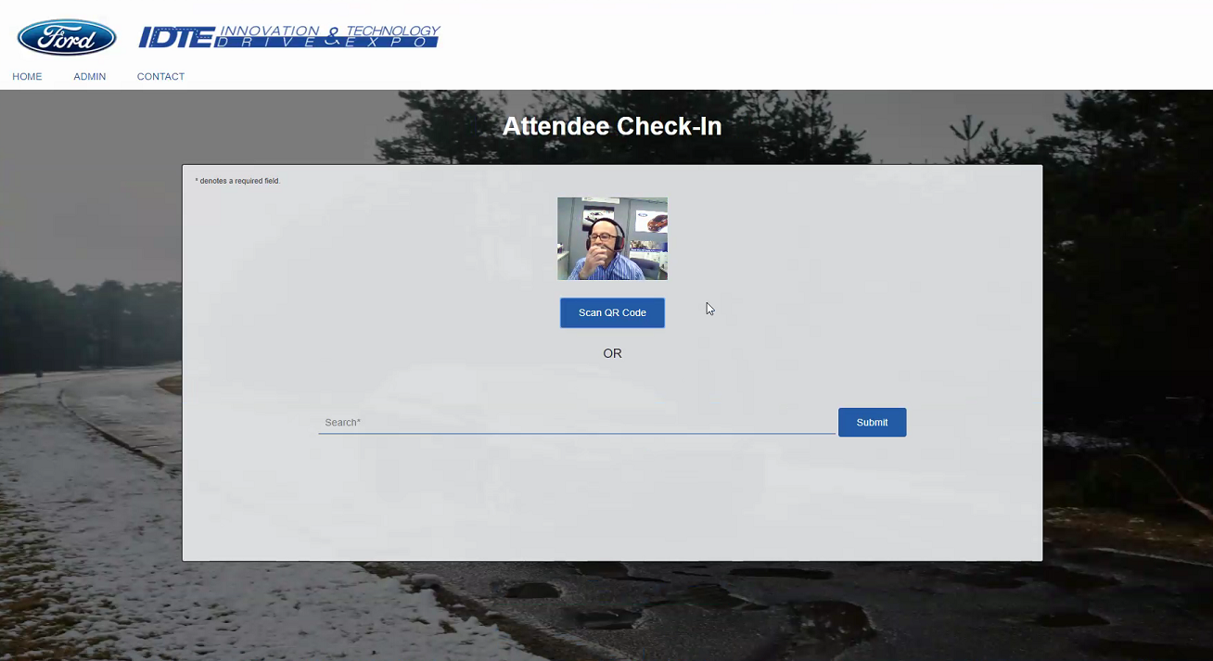

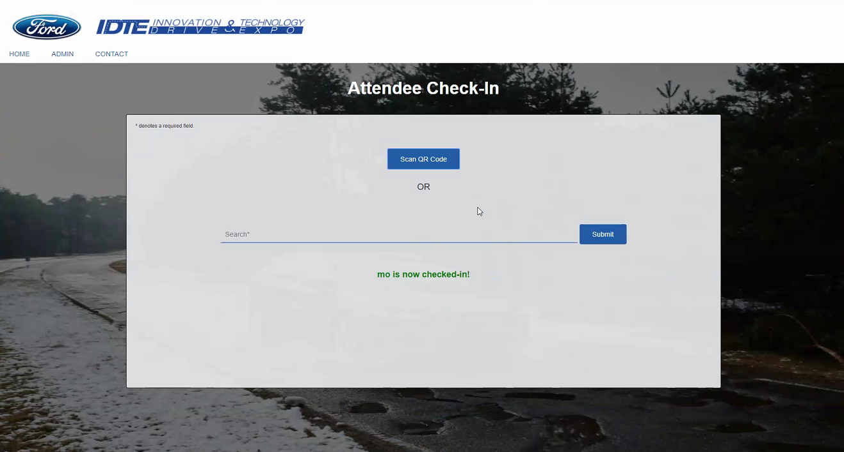

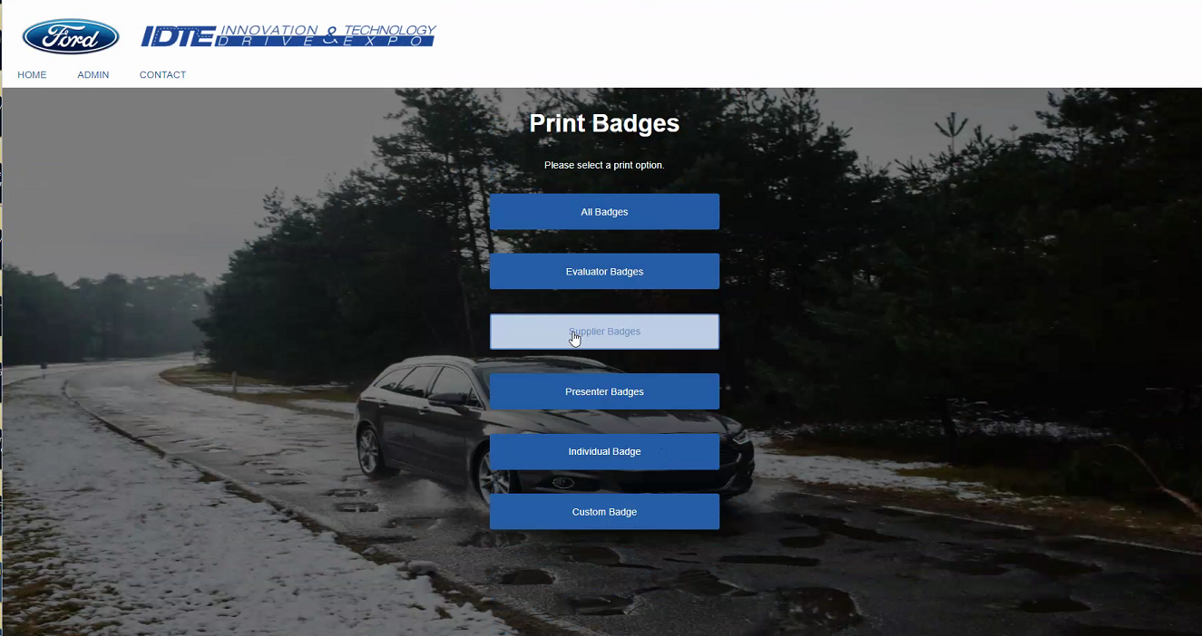

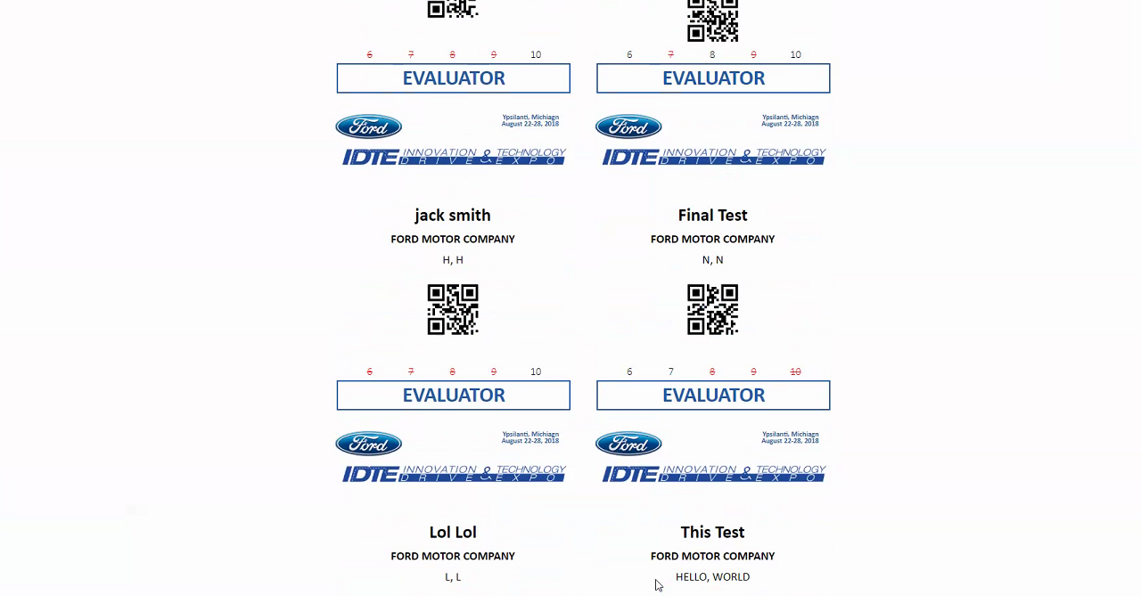

They have a SQL database for the Evaluation Team’s work.

And they are creating a web interface for that

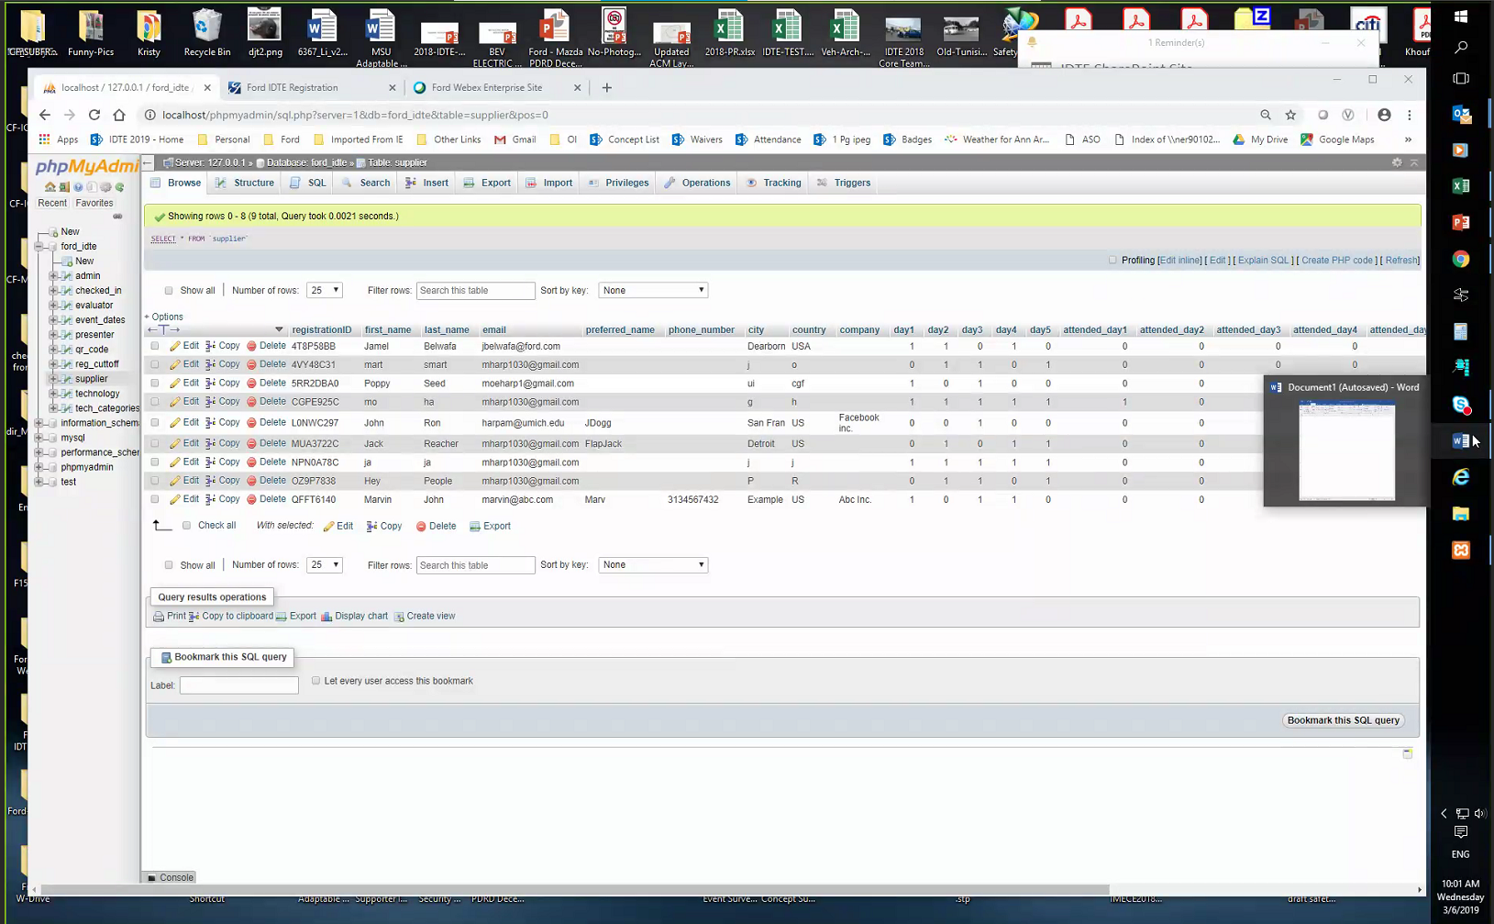

Students used MY SQL

A sharepoint list to receive all email and manage it may be better then have a batch job to sync up the SQL database

Walter joined the meeting

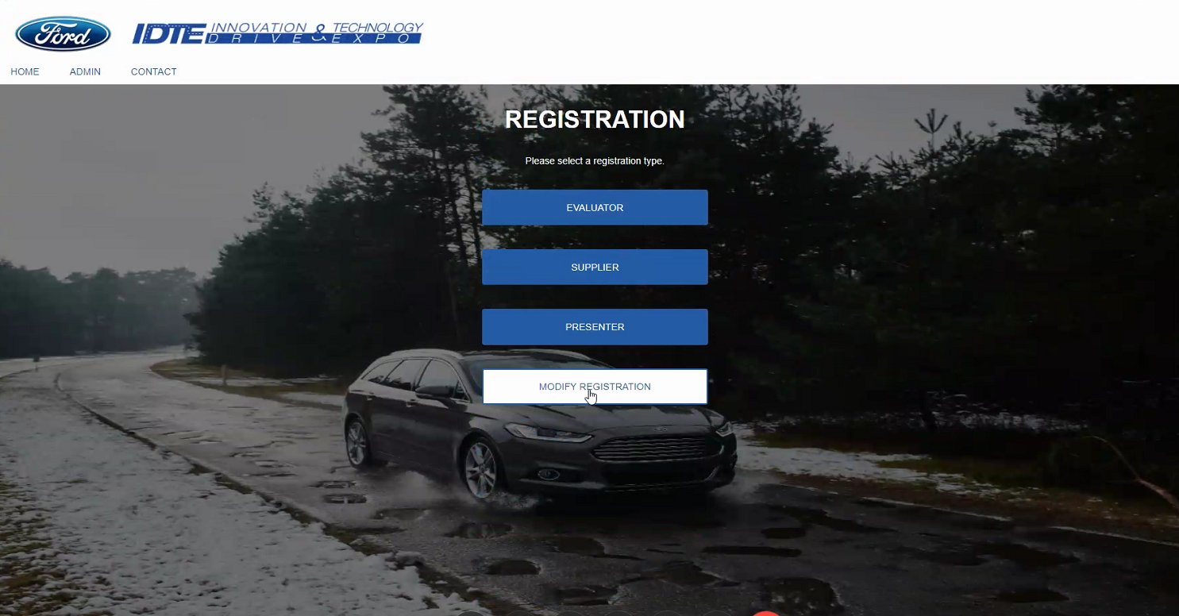

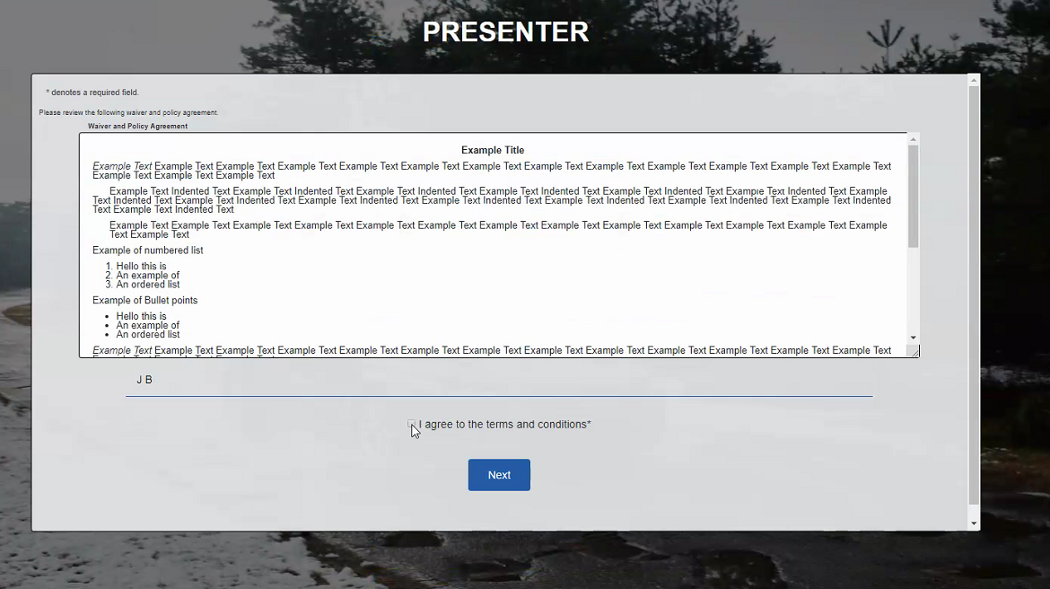

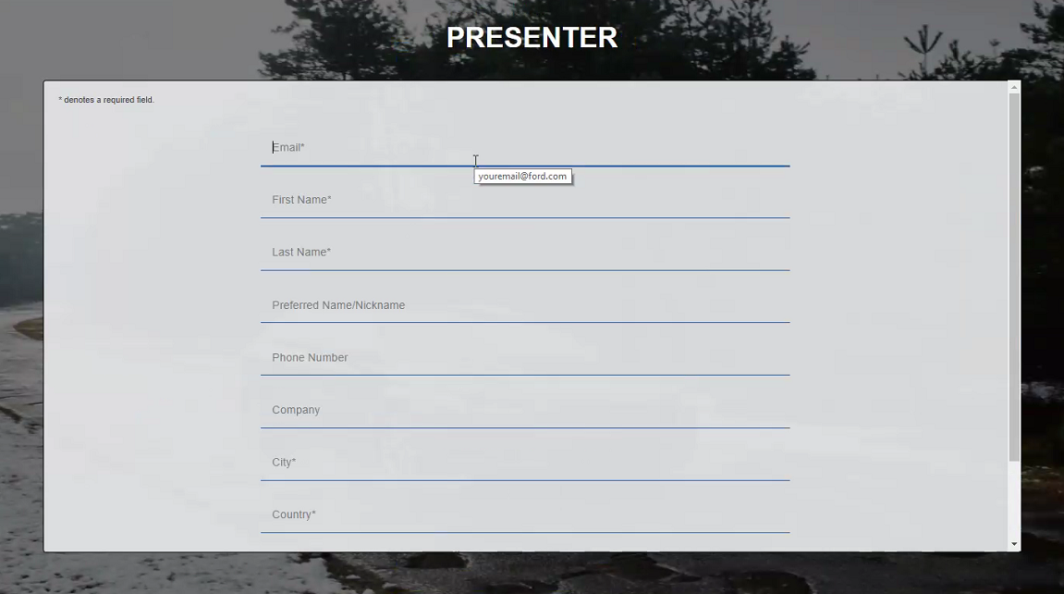

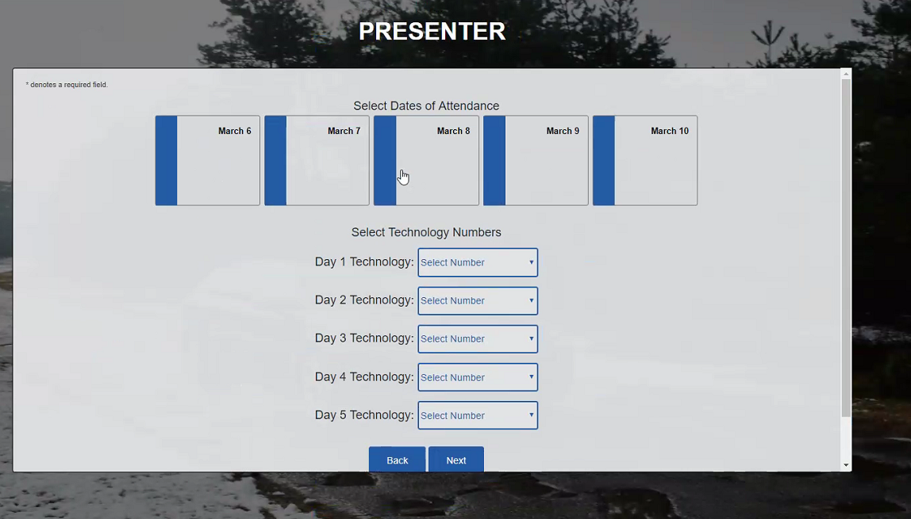

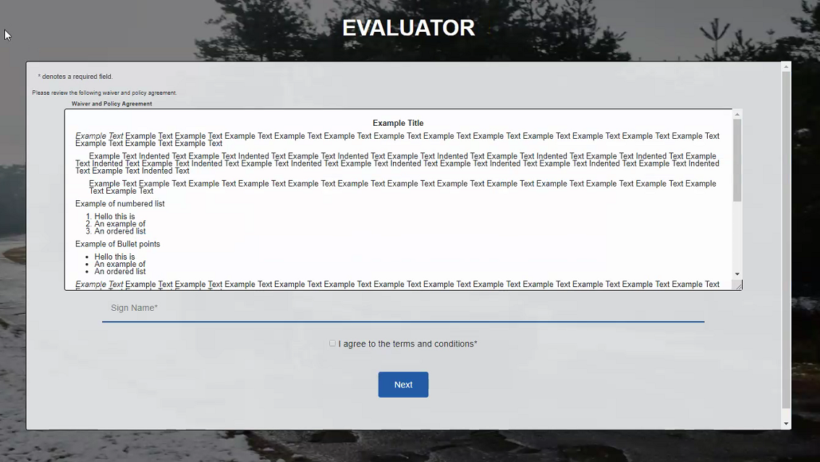

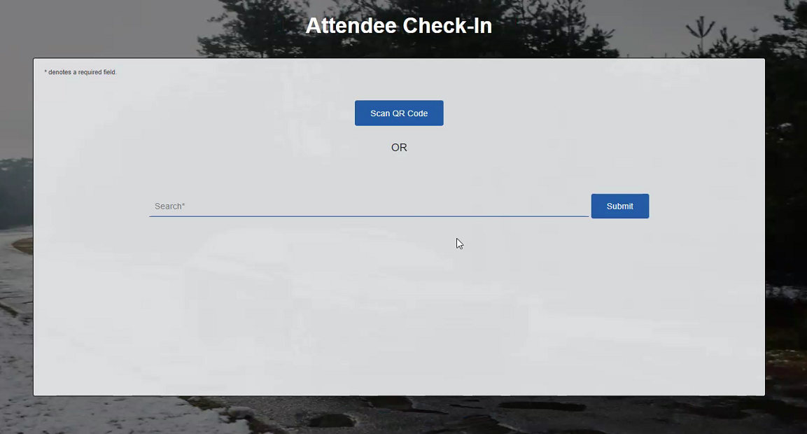

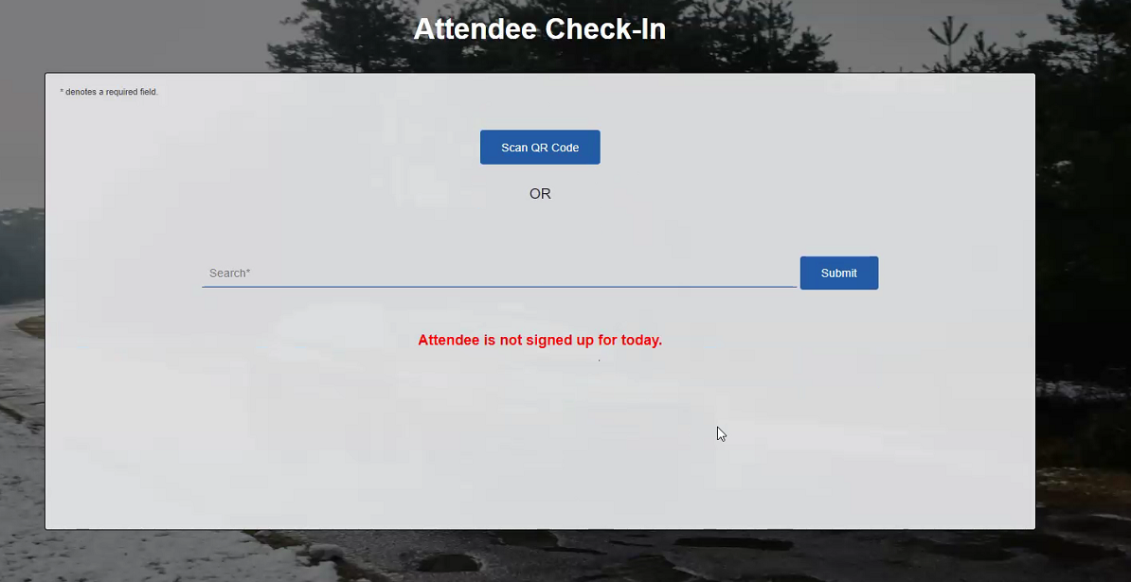

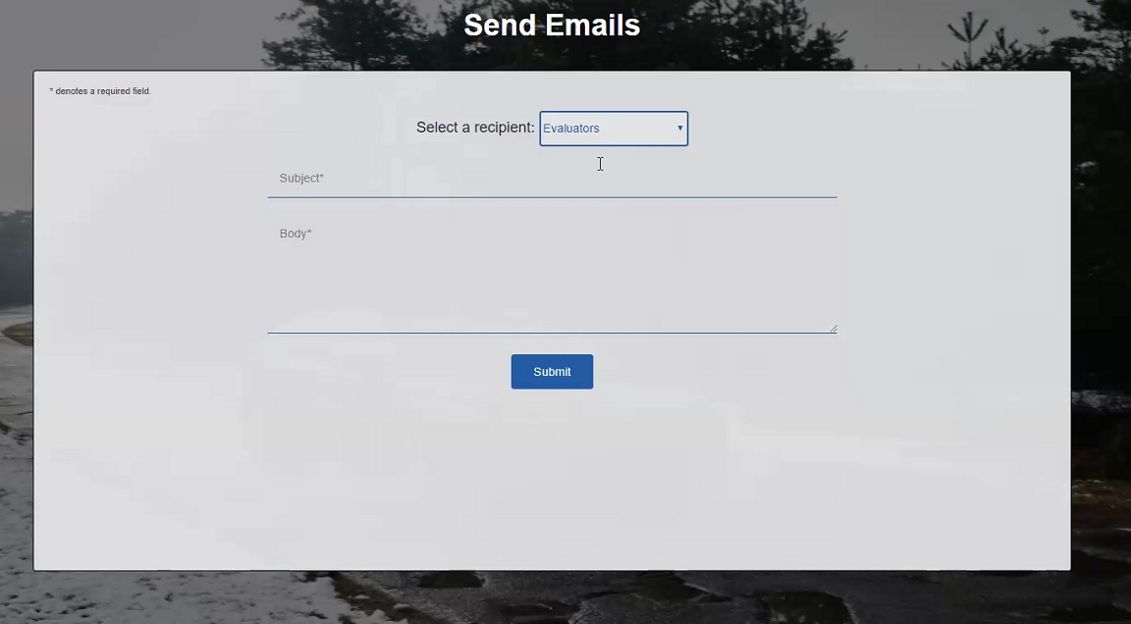

Enhancement is to send email to evaluators on that day

Question about the QR code compativility in Europe

SQL database may not need the SharePoint list data

The students interface is worthy of being leveraged by the SQL Team

Jamel

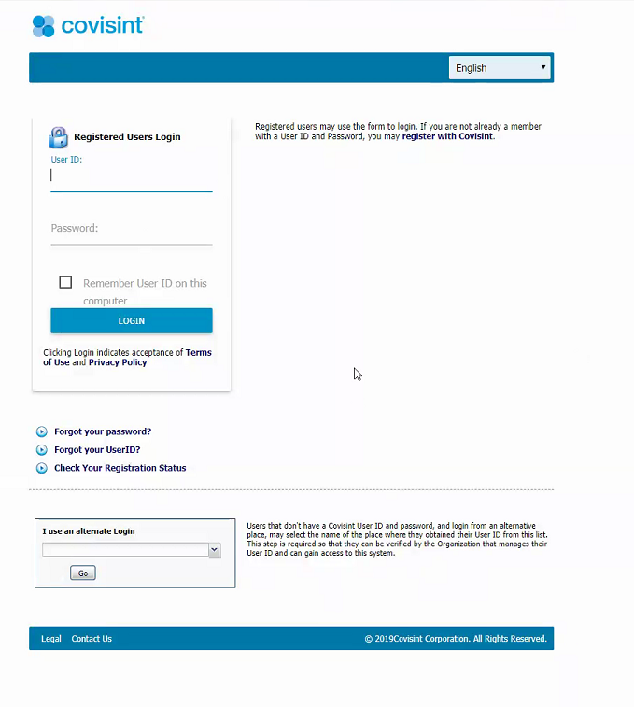

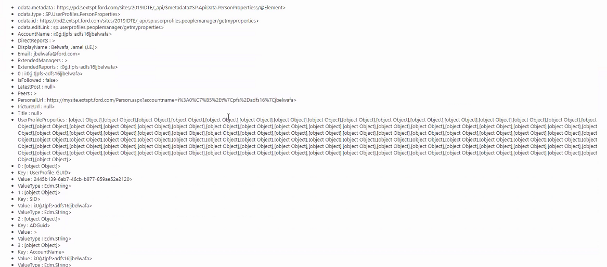

Peter

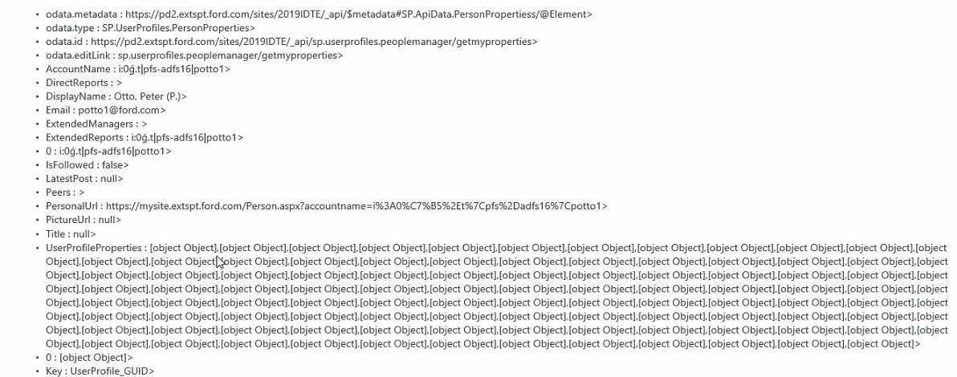

Concept Type

Add shipping from

Source

Originated by Ford Motor Co

Originated by Supplier

Auto populate country as you are typing

Add attachment button

Remove the status from view

Add facilitator and manager to record to idea submission

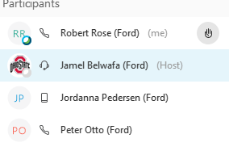

Talk tomorrow

What is the next steps

Approved High

Approved Med

Approved Low

Declined

Lookup field CDSID

Then pull in all the fields from the Submit ideas

Add status

Non ford will not see the ford email field

Build out the evaluator

Assigned a facilitator

Quick edit does not work IDTE sites

Works in Chrome but not IE

Build another list of all cities

Build another list of all countries

What is the external sites for cities and countries

Need a list for all the facilitator and their related Strategritigg concept

Same thing for the management

Source

Ford Led

Supplier Led

Ford/Supplier Partnership

Concept Type

Driving Vehicle (Drivable Demo)

Static full Vehicle

Static Display (Buck or Parts)

Strategic Imperative

AI, Robotics & Controls

Automated Driving

Connectivity

Data Infrastructure & Analytics

Electrical & Compute Architecture

Electrification

FinTech

Interaction & Design Technologies

Internal Combustion Propulsion Systems

Materials & Manufacturing

Modeling & Simulation

Safety

Vehicle Architecture

Issues

When creating the Assign Facilitator lookup field, the new field information shows facilitators but does not show the Strategic Imperative in the additional fields to include

Country list

<https://wwwdev.gdd.ford.com//gddWAR/preferences/UserPreferences.jsp?back=https://wwwdev.gdd.ford.com:443/gddWAR/gdd&_page=ElementPage&_action=VIEW&t=22&id=828125>

Jamel wants a different country city drop list. He will research

CAN WE automatically populate the Strategic Imperatives

Disclaimer page may not be needed

Non Disclosure Agreement

<https://pd2.extspt.ford.com/sites/2019IDTE/SitePages/Ford%20Home.aspx>

The DW Team is They are Maru's team.

Maru Flores.

Jamel got an unexpected authentication approval request sent to his email.

For more information from Ford hub on the Supplier authentication see

<https://it1.spt.ford.com/sites/SP2016Reference/b2b/Pages/Supplier-Access.aspx>

feedback collection workflow template Is not available in external site

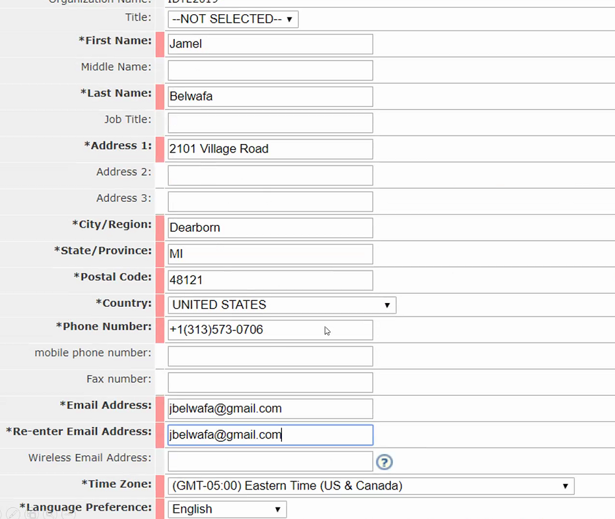

nICHOLAS FROM GERMANY CAN TEST [EDAG@FORD.COM](mailto:EDAG@FORD.COM)

we have another week